# Online Book Store Application C3

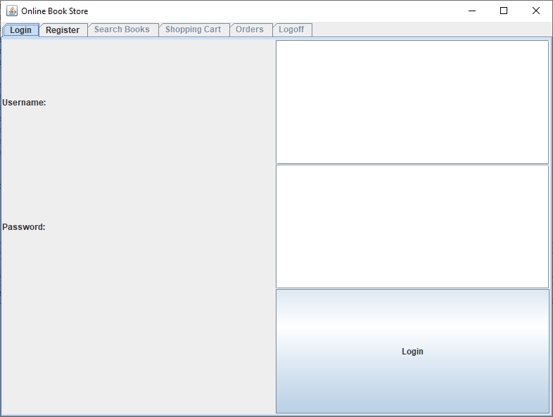

## Search:

## Add to Cart:

## Shopping Cart

## Checkout

